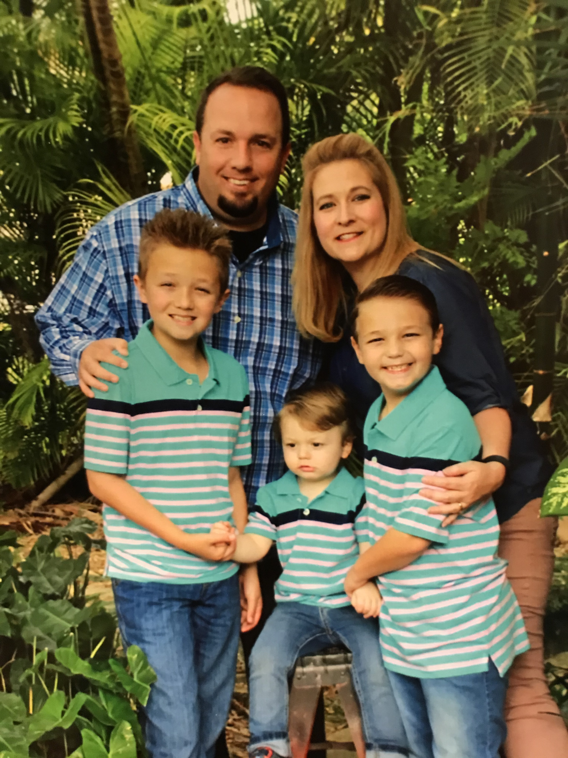
Objective
Dedicated Pastor with solid experience working with adults of all ages and teenagers. Maintains a strong desire to serve adults and families and helping them move towards becoming strong godly leaders, passionate servants of Jesus, and cravers of God’s Word.

Life Story
I grew up in a large church, First Baptist Church of Perrine which later became Christ Fellowship Miami. I served in different ministries while there, including Media and as a Small Group Coach. I gave my life to Jesus Christ at age 18. I also taught at the church Academy. My beautiful wife, Julie, who grew up as a pastor’s daughter, and I have been serving together in the ministry for 14 years. I did an incredibly insightful internship under Dr. Eric Geiger, former Executive Pastor at Christ Fellowship and Vice President of Lifeway Resources. I started my first church staff role as a Youth Pastor in Coral Springs and then after 2 years, I was called as Youth Pastor at New Beginnings Homestead (SB church). When the previous Senior Pastor retired, I was asked to serve as the Interim Pastor. A few months later the church voted me in as their Senior Pastor. Within my time there: the church has doubled in size, we have added staff, including a Kids Ministry Director, Financial Director, and Media Specialist. Many new families have come to know Christ and we have also started a second service. We raised over a half-million dollars to fully renovate our Sanctuary and Fellowship Hall. The church is currently debt free. My wife teaches Music and is the Chaplain at Florida Christian School. Julie and I have 3 boys, Jaden, Jarrett and Jaxson.

Experience
New Beginnings Christian Fellowship September 2010 – Present (786) 208-1043
- Senior Pastor
- Youth Pastor

Coral Springs Community Church August 2008-September 2010 (954) 326-1047
- Youth Pastor

Education / Certificates
- Trinity International University, Davie, Florida, Spring 2006-2010- Bachelor of Arts Program-Christian Ministry-Graduation Day May 2010
- Miami Dade College, Kendall, Florida, Fall 2001-Fall 2004
- Miami Palmetto High School - May 2001
- Certification in Conflict Strategies Inventory
- University of Boston School for Technology training

References
- Dr. Gary Johnson, Executive Director of Missions, Miami Baptist Association, 786-280-8081, garyj@mbachurches.org
- Mrs. Pamela Armstrong, Family Life Director, Princeton Church, 305-257-3644, parmstrong@princetonchristian.org
- Reverend Jeff Sullivan, Executive Pastor, Granada Presbyterian Church, 305-898-6169

