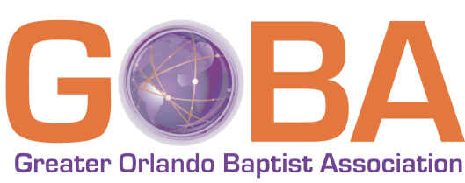
Greater Orlando Baptist Association
New Membership Affiliation Request

Welcome…
We look forward to connecting with you as team members! As brothers and sisters in Christ, we want to join in fellowship and cooperation with you in advancing the cause of Christ as described in Matthew 28:18-20. Please let us know how we can assist you as we start down the road together.

The Churches of the
Greater Orlando Baptist Association

Our request…
To help you know us, a copy of the Greater Orlando Baptist Association (GOBA) Bylaws is available for your review online. In return, we want to get to know you by asking for some information, including your Statement of Faith, Bylaws, etc. The Credentials Committee is available for clarification/assistance. Our contact information:
Email – goba@goba.org
Address – Greater Orlando Baptist Association, 1906 W. Lee Road, Orlando, FL 32810

Key steps…
As you proceed, please let us know your progress and/or any questions by email or phone.
- Please fill out the below application pages and return by mail or email.
- Please mail or email a copy of each of the following. 1) Articles of Incorporation, 2) Covenant/Constitution and Bylaws, 3) Statement of Faith, and/or 4) other similar documents.
- Application may be submitted at any time, but full documentation must be submitted no later than August 1 for consideration at the next Greater Orlando Baptist Association Annual Meeting.

Church Information…
Our church wants to join with GOBA for the purpose of cooperating in advancing the gospel and promoting the cause of our Lord Jesus Christ in our local church area and around the world. We want to meet and start planning for this partnership with Greater Orlando Baptist Association leadership as soon as possible.

Name of Church/Mission ________________________________________________________________

Church Phone ________________________________ Church Fax _______________________________

Address ______________________________________________________________________________
Street address/mailing address, if Different/City/State/Zip

Email ____________________________________ Website ____________________________________

Resident Membership __________ Present Attendance in Worship Services (s) __________

Pastor’s Name _________________________________________

Pastor’s Home Phone ____________________ Pastor’s Email ___________________________________

Pastor’s Home Address __________________________________________________________________
Street address, mailing address/City/State/Zip

Church Affiliations…
Date church began as a mission ________ Sponsor Church _____________________________________

Sponsoring Church Pastor _______________________________ Phone __________________________

Date joined Southern Baptist Convention __________ with planned Cooperate Program support of _____% and Greater Orlando Baptist Association support of _____%.

Other Association affiliations (previous and/or current) ________________________________________

We need help from GOBA to: _____________________________________________________________

We can also offer help to GOBA by: ________________________________________________________

Church Faith and Practice…
Describe the basic tenets of your faith: _____________________________________________________

Describe your views of the current Baptist Faith & Message: ___________________________________

_____________________________________________________________________________________

Church’s Public Witness…
Describe your worship services: ___________________________________________________________

Describe your Bible Study/other training programs: ___________________________________________

What literature do you use? ______________________________________________________________

How do you do mission work? ____________________________________________________________

How do you do local evangelism? _________________________________________________________

Church Roles and Relationships…
Describe the pastor’s role as seen by the congregation: ________________________________________

Describe the pastor’s view of the role of the congregation: _____________________________________

How do your business meetings function? __________________________________________________

Who is the Moderator? _________________________________________________________________

How is the collections and distribution of funds handled? ______________________________________

Other information…

_____________________________________________________________________________________

_____________________________________________________________________________________

_____________________________________________________________________________________

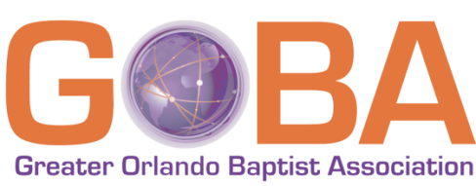
Greater Orlando Baptist Association
New Church
Request for Affiliation

Being in agreement with the nature and purpose of the Southern Baptist Convention and the Greater Orlando Baptist Association, we hereby request to affiliate this body with the Greater Orlando Baptist Association for the purpose of cooperating in advancing the gospel and promoting the cause of our Lord Jesus Christ in our local church and around the world.

Name of Church/Mission ________________________________________________________________

Address ______________________________________________________________________________

Statement of Cooperation

We agree to join fellowship and cooperate with Greater Orlando Baptist Association in fulfilling the Great Commission.

We further agree to demonstrate cooperation by:

- Maintaining a faith and practice consistent with historic Southern Baptist principles.
- Maintaining a cooperative relationship with the Greater Orlando Baptist Association, its churches, the Florida Baptist Convention, and the Southern Baptist Convention.
- Participating regularly in Greater Orlando Baptist Association activities, particularly Executive Board and Annual Meetings of the Association.
- Give at least 8% and 2%regularly to the Cooperative Program and the Greater Orlando Baptist Association respectively from general church contributions.
- Submitting an Annual Church Profile (ACP) by October 7th of each year.

This done by vote of the church in business meeting, this _______ day of _____________, 20____.

Moderator or Pastor _______________________________________________________

Church Clerk ______________________________________________________________

Note: Please complete and forward all pages by email or mail.

